Discussion: How does a submarine sink and float?
Investigating how a Submarine Sinks
and Floats

A submarine is a vessel that can float or sink. Unlike a ship, a submarine can control its buoyancy, allowing it to float, sink and come back up to the surface of the water. A submarine can dive up to 240m under the water.
A submarine has a special system called and external and internal ballast tanks.
When the submarine travels on the surface of the water, the ballast tanks are pumped full of air from high-pressure compressed air tanks. The external ballast tanks have openings at the top, which can be closed by valves. When the air is trapped inside the ballast tanks, it makes the whole submarine lighter than the water in which it sits and the submarine floats.
When a submarine submerges or dives down, its ballast tanks are flooded with water.
The ballast tanks have grates and vents on the bottom. The vents can be opened to control the amount of water that enters the ballast tanks. The water entering from the bottom, forces the air up and out of the ballast tanks.
The displacement of water creates an upward force. This makes the submarine negatively buoyant and pulls the submarine down.

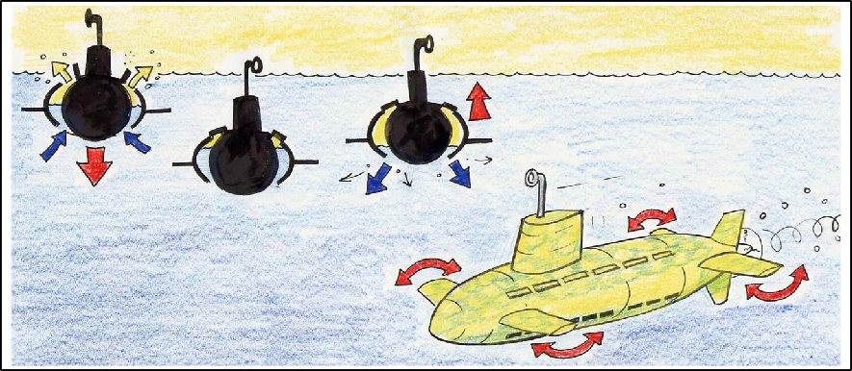
Illustration© John Joyce, 2006
The illustration shows how ballast tanks are used to make a submarine sink and float.

Once the required depth is reached, a specially trained crew member called the Diving Master, can change the amount of water and air in the ballast tanks until the submarine is the same weight as the water and the submarine neither floats or sinks.

At this point, motor-driven propellers are used to move the submarine along. It also has special swivelling fins called hydroplanes located on the side of the submarine. These are used to direct the submarine up and down underwater.

When the Captain of the submarine wishes to surface, high-pressured air stored in compressed air tanks is blown back into the ballast tanks This air forces out the seawater and the vessel begins to rise to the surface. The submarine becomes lighter than the water that surrounds it, and the submarine then float.
Experiment to demonstrate how
a submarine floats?

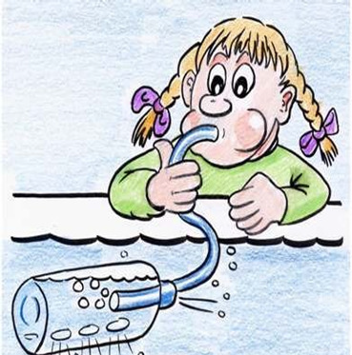
Illustration© John Joyce, 2006
Materials:

- A deep basin of water (or use the bath)
- Small recycled plastic bottle
- Plasticine
- A bendy straw or a small clean tube
- Scissors (a parent will need to help younger children with cutting holes in the bottle)

Instructions:

- CAREFULLY – make a straight line of holes along the edge of a plastic bottle from the top to the bottom. (Take the lid off the bottle before cutting to release the air pressure inside it - otherwise it will be difficult to cut into the bottle). Safety note: get an adult to cut the holes in the bottle.
- Mould a piece of plasticine around the bendy part of the drinking straw to use to seal out the water.
- Place the shorter end of the plastic drinking straw through the top of the bottle, bending it so that it sticks up like a periscope. Press the seal in place around the top of the bottle and straw.
- Submerge the bottle in the water with the holes upwards so that the bottle fills with water and sinks -this is like a submarine diving. A little bit of force may be required to sink the bottle. You may need to gently push down on the bottle to force the air out of the bottle, so it fills with water and sinks.
- Now turn the bottle the other way around so that the holes are facing downwards. The bottle is neither sinking or floating - this is like the Captain shutting the top vents on the ballast tanks.
- Gently blow into the straw. Students are now “blowing ballast” – watch how blowing in air forces water out of the bottle

Results of my experiment
bmarines

Worksheet: Investigating how a Submarine Sinks and Floats

Explain what happened in your demonstration:
- What happened to the “submarine” when water was allowed into the vessel through the holes (e.g. ballast vents) – Did it sink or float? _______________________________
_______________________________________________________________
- What happened to the “submarine” when water is forced out of the bottle - Did it sink or float? ___________________________________________________________
__________________________________________________________________________

re ab Quiz on how submarine’s float and sink
out submarines

Fill in the missing letters to find the answer:
- What is the special system called that helps a submarine float and sink? B _ _ _ _ _ _T_ _ _ _ .

- When the submarine travels on the surface of the water, the ballast tanks are pumped full of _ _ R. This makes the whole submarine L_ _ _ _ _ _ than the water in which it sits and the submarine floats.
Circle the correct answer:
3. When a submarine submerges under the surface of the ocean, its ballast tanks are flooded with:
A. Air B. Water C. Fish
4. The displacement of water creates an upward force. This pulls the submarine down. What does displacement mean?
A. Movement B. Calmness C. Motionless

Why would submarines be useful
for exploring the ocean?

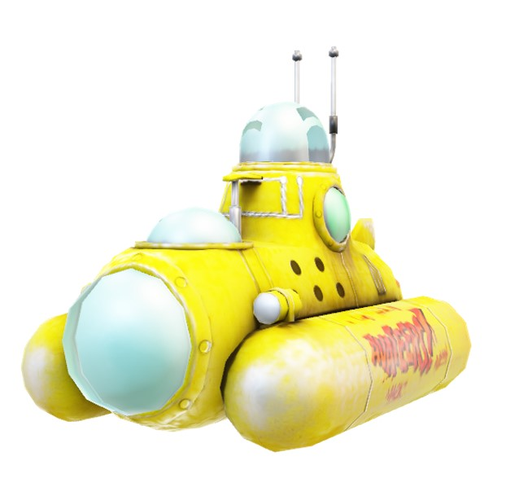

_____________________________________________________
_____________________________________________________
____________________________________________________
___________________________________________
__________________________________________
____________________________________________
Think about how long you could stay under the water, how far you could travel, and what you might discover?

